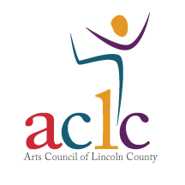Prizes 1st Place-$50 2nd Place—$35 3rd Place—$25
Contact Name: ________________________________________________________________
Address: City, State, Zip: ___________________________________________________________
Cell Phone (needed for onsite communication): _____________________________________
E-Mail: _______________________________________________________________________
Pound Cake: ____________________________
Sweet Potato Pie: ________________________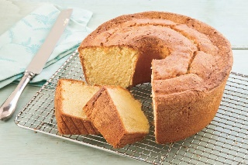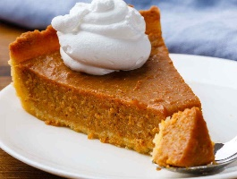
$5 per entry

Rules ♦
Contestants must be pre-registered. Registration can be done at The Arts Council of Lincoln County, 403 E. Main St Lincolnton or www.artslincolnnc.com. Registration will be from April 15th to June 7th.
♦ Entries requiring refrigeration will not be accepted.
♦ Pound cake/Sweet potato pie must be submitted on or in a disposable container.
♦ Entries must be made from scratch. No prepared mixes allowed.
♦ All entries must be checked in between 9:00am and 10:00am on the day of the contest.
Check-In will be at the Pound Cake/Sweet Potato Pie Contest Tent.
♦ No cake/pie or cake/pie container will be returned.
Judging Criteria Maximum total points is 100.
Taste—40 points Appearance—20 points Consistency—20 Points Creativity—20 Points

All entries will become the property of the Arts Council of Lincoln County and the cakes/pies will be sold by the slice during the festival. Proceeds will go to the Juneteenth Festival committee.

